GPDHOST pour héberger en ligne

Django MTV: Model Template View

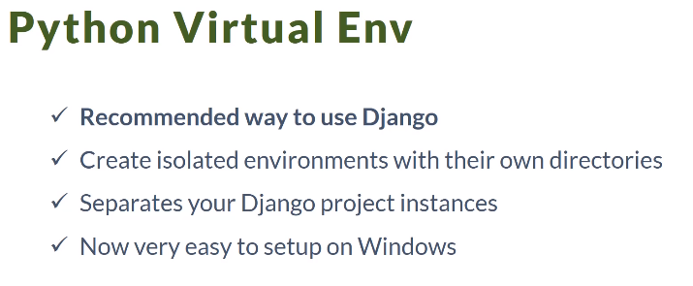

<https://docs.djangoproject.com/en/1.11/ref/settings/#databases>

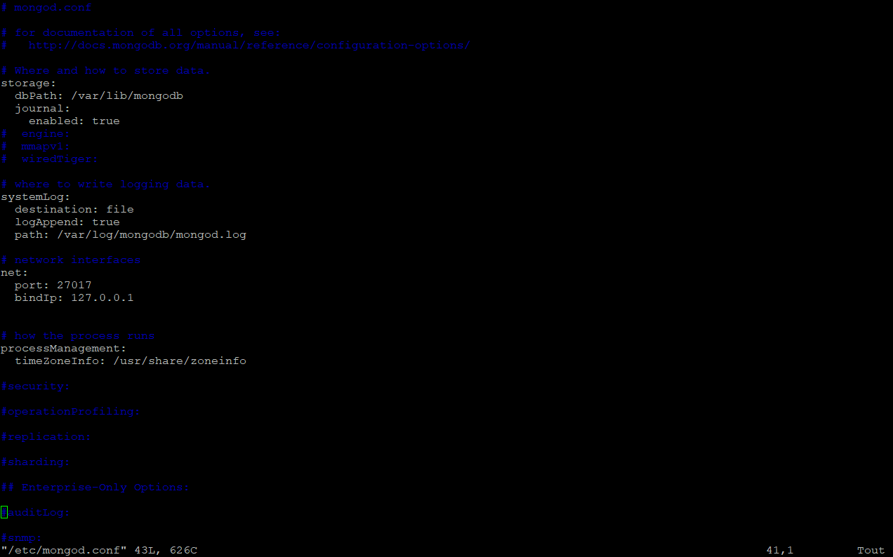

Mongod to config

<https://github.com/nesdis/djongo/blob/master/README.md>

<https://docs.djangoproject.com/en/1.11/ref/settings/#databases>

<https://nesdis.github.io/djongo/integrating-django-with-mongodb/#a-quick-sanity-test>

<https://www.youtube.com/watch?v=-vXlfRk6yaw>

<https://api.mongodb.com/python/current/>

<https://www.youtube.com/watch?v=D6esTdOLXh4>

<https://developer.mozilla.org/en-US/docs/Learn/Server-side/Django/skeleton_website>

<http://apprendre-python.com/page-django-application-creer-python>

<https://www.tutorialspoint.com/django/django_url_mapping.htm>